

**First Review**

**For**

**Second Year Project**

**Bachelor of Science in Information Technology**

**Tic-Tac-Toe Game**

**Submitted by**

**Gyeltshen wangdi (12190053)**

**Gyalpozhing College of Information Technology**

**1. Introduction**

A. Purpose

The aim of the project is to develop an application called as Tic-Tac-Toe game, that can help a student to improve their mental as well as logical power.

**OBJECTIVES:**

1.To entertain a student to develop their logical Stagey in terms of winning the game

2. To enhance student logical Stagey

## B. Scope System scope

## The scope of the project is limited to the (GCIT) students.

## Since I am going to developed a simple android base game with the following features:

## Start

## Restart

## Exit

## Score

## User scope:

My application is limited to( GCIT) students.

**2. Requirements**

a. Functional Requirements: Describe each feature of your application

This are some of the features that will be included in our application:

## Start: It is use to start the application

## Restart: it is the process where the user or player can restart their game play after completion of the game.

## Exit: it is the process where the user can close the application after enjoying the game.

## Score: the player can view their score, according to their wish.

b. Non-functional requirements

Some of the non-functional requirements of our application are:

1. Security
2. Portability and compatibility

My gamming application is portable as well as compatible as it can be supported in all the platforms of android versions.

1. Usability

My application will be very easy to use as:

1. Learnability: The users will be able to use application very easily since, it is simple and easy to use.
2. Errors: The users will not make many mistakes as the features will be named specifically with icons.
3. Memorability: Since my gamming application is not complex, the users will not face trouble.

c. Software Requirements: The technology used and version

The technology that is used for developing this application is

* Android studio (Version: 4.1.2 and Gradle Version: 6.5)

Android Studio is the official integrated development environment for Google’s Android operating system, built on JetBrain’s IntelleJ IDEA software and designed specifically for Android development.

* Java Development Kit

The Java Development Kit is an implementation of either one of the Java Platform, Enterprise Edition, or Java Platform, Mirco Edition platforms released by Oracle Corporation in the form of a binary product aimed at Java developers on Solaris, Linux, macOS or Windows.

**3. Hardware Requirements**

**- Users Requirement**

1. 4-8GB RAM

2. 2.00GHz*4 Processors

3. Android Phone (Emulator)

Hardware requirements for Windows OS:

1. Microsoft Windows 7/8/10 (64 bits)
2. 4 GB RAM minimum, 8 GB RAM recommended
3. 2 GB of available disk space minimum, 4 GB recommended (500 GB for IDE + 1.5 GB for android SDK and emulator system image)
4. 1280 * 800 minimum screen resolution

Hardware requirements for Linux OS:

1. GNOME or KDE desktop Tested on gLinux based on Debian
2. 64-bit distribution capable of running 32-bit applications
3. GNU C library (glibc) 2.19 or later
4. 4 GB RAM minimum, 8 GB RAM recommended
5. 2 GB of available disk space minimum, 4 GB RAM recommended (500 GB for IDE + 1.5 GB for android SDK and emulator system image)
6. 1280 x 800 minimum screen resolution

**4. System Design**

a. ERD (Entity Relationship Diagram)

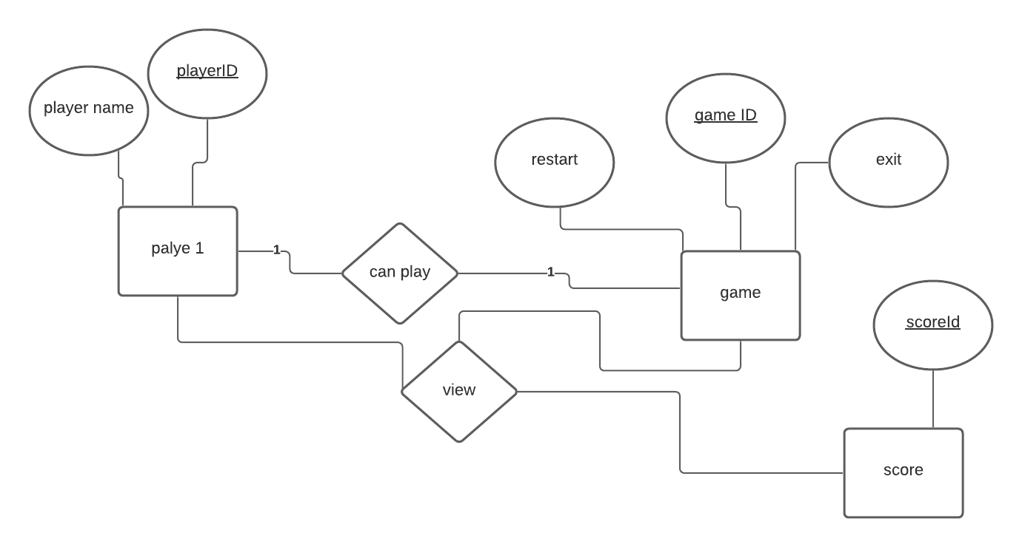In our Entity Relationship Diagram, we have identified three entities and they are player, game, score in which these entities are connected with relationship. We have two relationships and they are:

1. can: The player can start the game
2. score: The score can be view by player and the game has a score

b. Relational Schema

player

|  |  |
| --- | --- |
| Player Name | Player id |

Game

|  |  |  |  |
| --- | --- | --- | --- |
| (f.k) player id | restart | exit | Game id |

Score

|  |  |  |
| --- | --- | --- |
| Score id | (f.k) Player id | (f.k)Game id |

1. Sequence Diagram

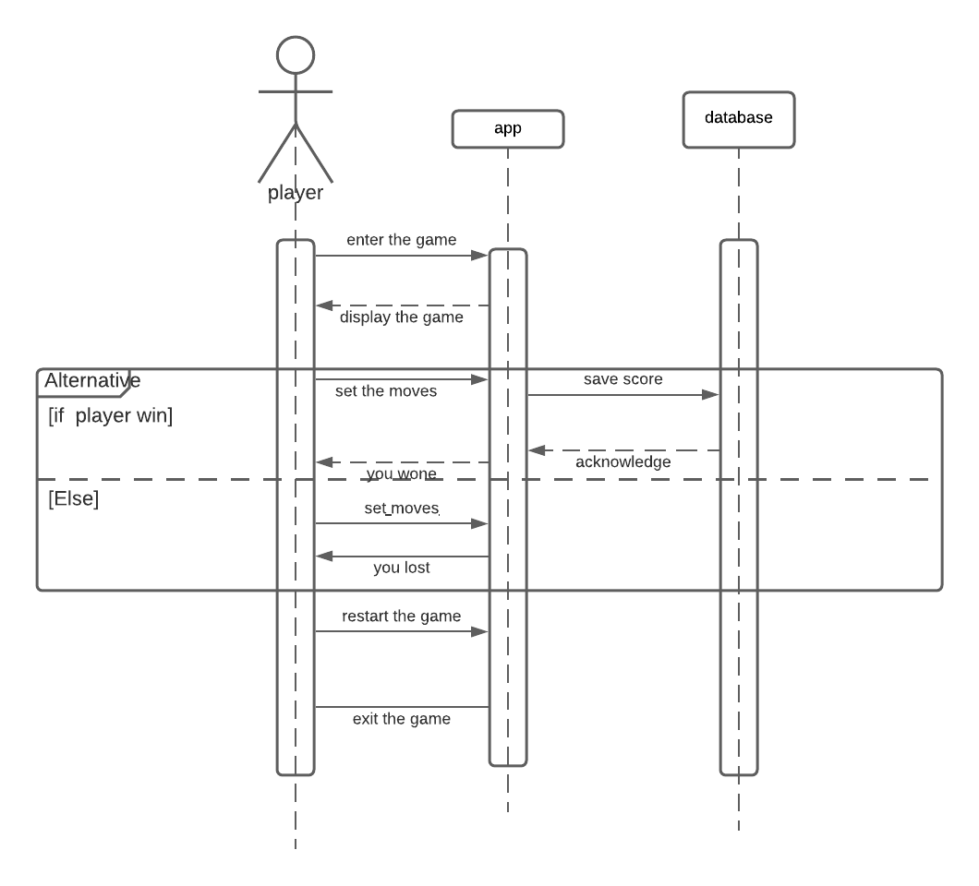

1. Use case Diagram

